Product Requirements Document
DASHBOARD - Display

Issued by | Role/Department | Date

REVISION TABLE

Version | Date | Issued by | Description
A-1 | 28/01/2025 | Alessandro Zingaretti
A-2
A-3
B-1
B-2
B-3
B-4

TABLE OF CONTENTS
GENERAL PRODUCT DESCRIPTION 3
REGULATORY 4
INPUT AND OUTPUT 4
ENVIRONMENT 5
INTERFACE 5
DESIGN 6
SOFTWARE ARCHITECTURE AND DATA PROCESSING 6
ERRORS 7
ELECTRICAL HARDWARE AND SENSORS 7
PRODUCT VALIDATION / QUALIFICATION 7

GENERAL PRODUCT DESCRIPTION
Product Description
Key Features/ Functionality | Showing car parameters on the steering wheel display (car speed, critical temperatures, R2D, SOC and power consumption,…)
HV/LV | LV
Software | Nextion Editor, STM32CubeIDE
Software Language | C/C++, Nextion language
Other components Compatibility,
Ecosystem, etc.
Installation (where) | NX4832T035, STM32F303K8T6
Dimensions and Tolerances | Nextion: 100.5 (L)×54.94 (W)×5.45 (H) (.X$±$,20)  Stm32:
Connections
Weight | Nextion: 38.2g

REGULATORY
Regulatory Requirements
Safety
Structural
Electrical
Labeling
Regulatory Marks
Place of Origin
Serial Number
Financials
BOM Cost
COGs
MSRP
Volume
Number of pieces
Spare Parts

INPUT AND OUTPUT
Product Description
Data Input (CAN/Bluetooth….) | Stm: CAN-BUS  Nextion: Serial
Signal Input | Stm: GPIO (Shift register, buttons)
Data Output (CAN/Bluetooth….) | Stm: CAN-bus, Serial
Signal Output

ENVIRONMENT

Operating Environment
Where in the car | Steering Wheel
Temperature Range | Nextion: (-20,+70)°C  Stm: (-40,+85)°C
EMI (vulnerability to electromagnetic interference)

INTERFACE
User Interface
Communication protocol
Communication Input
Communication output
Connector
Visual Interface  (Screen size and type, LEDs) | Nextion: 100.5 (L)×54.94 (W)×5.45 (H) (.X$±$,20)
External Software interface | STM32CubeIDE

DESIGN
Renderings | 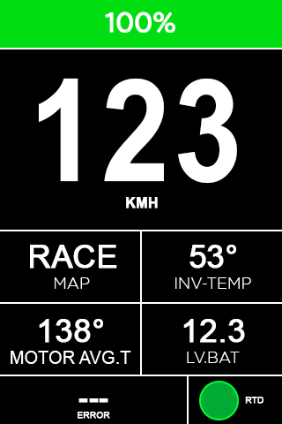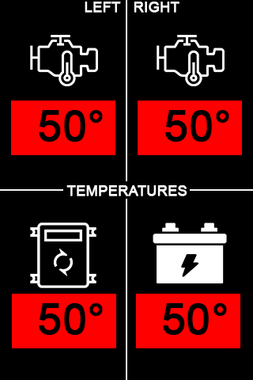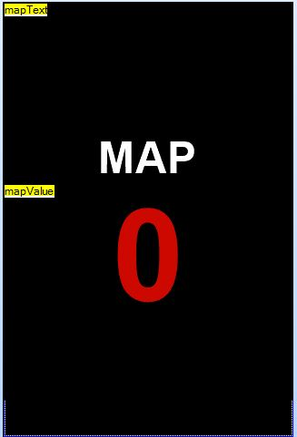
Color, Material, and Finish (CMF)
Logo size and placement

SOFTWARE ARCHITECTURE AND DATA PROCESSING

Block Diagram of Data Flow
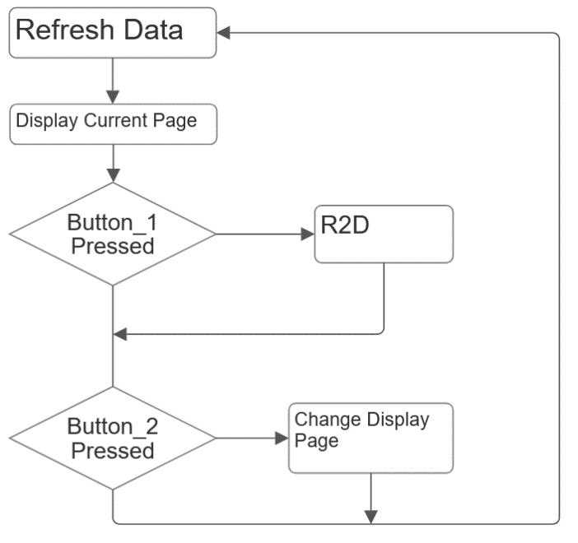
The code is used to manage the communication between the car and the user interface on the steering wheel. (display and buttons)
The software receive from CAN-bus the data to be displayed on the display. The data to be displayed are: SoC, inverter and motor temperature, speed,…. Once received and unpacked, they must be sent via serial to the display. In addition, the map selected by the hand controller is displayed.
The value of the hand controller is managed by a shift register (see above for the datasheet) and has seven possible positions. Each position corresponds to a map for engine control, which the driver can choose by turning the knob. The code reads the value of the selected map and send it both via CAN (0x040) and via serial for the display. In particular:
Hand controller’s Position | Display message | CAN message
1 | Map 1 (0%) | 0
2 | Map 2 (11-30%) | 1
3 | Map 3 (30%-60%) | 2
4 | Map 4 (60%-100%) | 3
5 | Error: Map not available! | 7
6 | Error: Map not available! | 7
7 | Error: Map not available! | 7

Button 1
This button manages the R2D (EV regulation 4.11). When the car reads the button pressed and the brake message (0x012) high, the R2D parameter (0x016) is set high.

Brakes (0x012) | Button 1 | R2D (0x016)
0 | 0 | 0
0 | 1 | 0
1 | 0 | 0
1 | 1 | 1

Button 2
Pressing this button changes the page on the display.

Parameters Definition
FAN speed map

ERRORS
Errors Parameters Definition
Critical parameter

ELECTRICAL HARDWARE AND SENSORS

Block Diagram of Electrical Hardware
Supply Voltage
Supply Current
Output
OverVoltage/ OverCurrent / Short Circuit Protection on power supply

PRODUCT VALIDATION / QUALIFICATION
Data Test
Visualization Test
Ergonomics Test
Utility Test

